**MORDERN APPLICATION DEVELOPMENT**

**(JAVA SPRING BOOT)**

**ASSIGNMENT-3**

**NAME**: KISHOTH KUMAR.A

**REGNO**:20MIS0411

**COLLEGE**: VIT-VELLORE

**BRANCH**: INTEGRATED M TECH (SOFTWARE ENGINEERING).

**GOOGLE DRIVE LINK**:

1. Implement JDBC Connectivity using java

**DATABASE CONNECTIVITY CODE**:  
java.sql.Connection;  
import java.sql.DriverManager;  
import java.sql.ResultSet;  
import java.sql.Statement;  
  
public class main {  
  
 public static void main(String args[]) {  
 try {  
 // 1.register the driver  
 Class.*forName*("com.mysql.jdbc.Driver");  
  
 // 2.connection  
 Connection conn = DriverManager.*getConnection*("jdbc:mysql://localhost:3306/university", "root", "kumarA@2002");  
  
 // 3.Statement  
 Statement stmt = conn.createStatement();  
  
 // 4.Execute query  
 ResultSet rs = stmt.executeQuery("select * from Stations");  
  
 while (rs.next()) {  
 System.*out*.println(rs.getInt(1) + " " + rs.getString(2) + " " + rs.getInt(3));  
 }  
  
 // 5.close the conenction  
 conn.close();  
 } catch (Exception e) {  
  
 }  
 }  
}

**SCREENSHOT**:

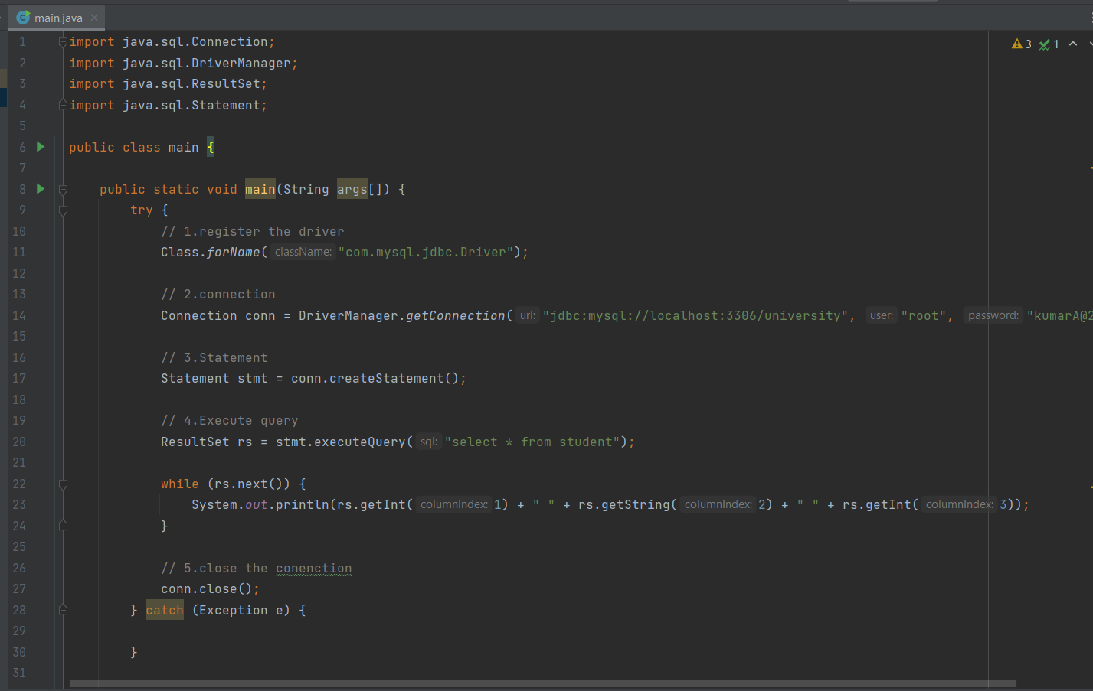

**DATABASE QUERY**:

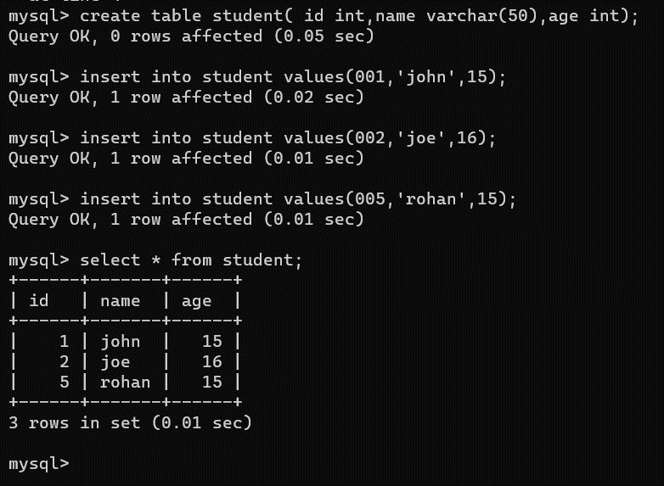

**CODE OUTPUT**:

